Amit Rizal

06/22/2025

Modules 5 & 6 Assignment - Working with CRUD-READ, JDBC, & JavaBeans

Creating Table

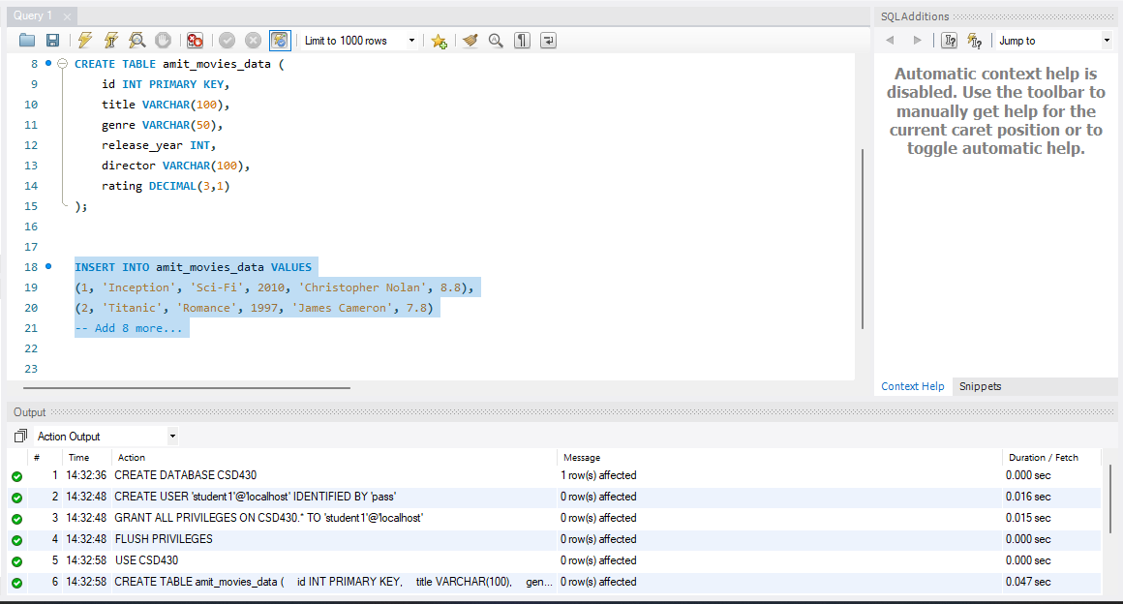

SELECT * FROM amit_movies_data;

